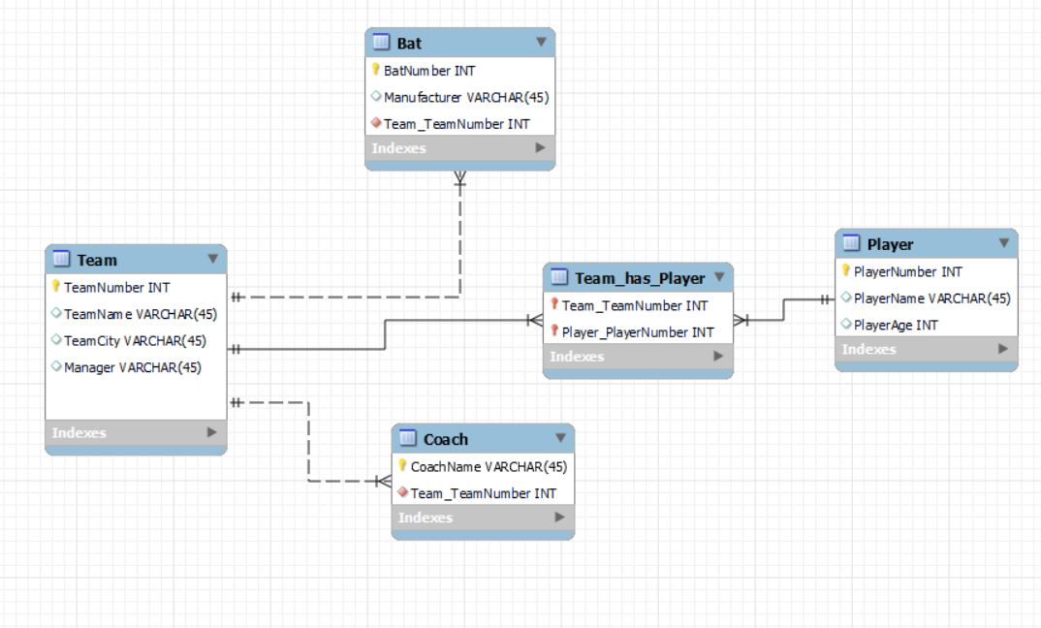

Orlando Junior Baseball wants to maintain information about its teams, their coaches, players, and bats.

The information about players is historic.  For each team, the league wants to keep track of all of the players who have ever played on the team, including the current players.  For each player, it wants to know about the player’s name, age, and every team the player ever played for.

Currently and historically, each team has and has had many players.  To be of interest to the league, a player must have played on at least one and possibly many teams during his career.

The league wants to keep track of each team’s team number, which is unique, its name, the city in which it is based, and the name of its manager.

Coaches have a name (which is only assumed to be unique within its team) and a telephone number.  Coaches have units of work experience, which are described by the type of experience and the number of years of that type of experience.  A coach works for only one team.  A team has at least one and usually several coaches.

Bats are described by their serial numbers (which are only unique within a team) and their manufacturer’s name.  Each team owns at least one and generally many bats.